The Race Day database design
I will use these six core entities:
- Users
  - Stores Organisers and Participants
  - UserID PK
  - Name, email, password hash, role, etc.
- Events
  - Stores races/events
  - EventID PK
  - Organiser FK
  - Event name, date, location, description, etc.
- Categories
  - Stores categories such as 10km Run, Half Marathon, 5km Walk, Cycling, etc.
- EventCategories
  - Connects Events to Categories
  - Allows an event to offer multiple categories
- Enrolments
  - Records participants entering a specific event category
- Results
  - Stores a participant's result for an enrolment

This gives a clean relational design and satisfies the minimum six-entity requirement. The assignment requires every relationship to show PK/FK information and cardinality.
Important role design
The assignment requires exactly two roles throughout the project:
Organiser
Can:
- Create events
- Edit events
- Delete events
- Manage categories
- Capture participant results
- View event enrolments
Participant
Can:
- Create an account
- Browse events
- Enter events
- Select an event category
- View their enrolments
- Track their own results
The assignment explicitly states that role-based access must eventually be enforced at the API level in Part 2 and reflected in the MVC application in Part 3.
Folder structure has been added below:

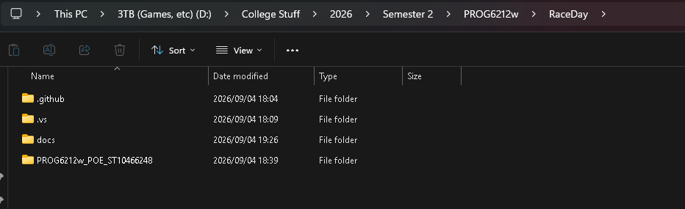
Basically:
RaceDay/
│
├── docs/
│ ├── RaceDay_ERD.png
│ ├── RaceDay_API_Endpoint_Plan.md
│ └── RaceDay_Database.sql
│
├── .github/
│ └── workflows/
│ └── validate.yml
│
└── README.md

SQL database
Our SQL script will include:
CREATE DATABASE RaceDayDB
and then:
Users
Events
Categories
EventCategories
Enrolments
Results
with:
- Primary keys
- Foreign keys
- NOT NULL
- UNIQUE
- DEFAULT
- Appropriate data types
- Referential integrity
- Sample data
The seed data must include at least:
- 2 Organisers
- 2 Participants
- 3 Events
- Categories for each event
- Sample enrolments
Those minimums are explicitly stated in the assignment.

API End point plan

We'll produce a table with exactly the required six columns:

HTTP Method | Route | Description | Role Required | Request Body | Expected Response
POST | /api/auth/register | Register account | None | User details | 201 / 400 / 409
POST | /api/auth/login | Authenticate user | None | Email/password | 200 / 401
GET | /api/profile | View own profile | Any | None | 200 / 401
PUT | /api/profile | Update own profile | Any | Profile fields | 200 / 400 / 401
GET | /api/events | Browse events | None | None | 200
GET | /api/events/{id} | View event | None | None | 200 / 404
POST | /api/events | Create event | Organiser | Event details | 201 / 400 / 401 / 403
PUT | /api/events/{id} | Edit event | Organiser | Event details | 200 / 400 / 403 / 404
DELETE | /api/events/{id} | Delete event | Organiser | None | 204 / 403 / 404
GET | /api/categories | List categories | None | None | 200
POST | /api/categories | Create category | Organiser | Category details | 201 / 400 / 403
PUT | /api/categories/{id} | Edit category | Organiser | Category details | 200 / 400 / 403 / 404
DELETE | /api/categories/{id} | Delete category | Organiser | None | 204 / 403 / 404
POST | /api/events/{id}/categories | Add category to event | Organiser | Category ID | 201 / 400 / 403 / 404
POST | /api/events/{id}/enrolments | Enter event | Participant | Category ID | 201 / 400 / 401 / 404 / 409
GET | /api/enrolments/my | View own enrolments | Participant | None | 200 / 401
GET | /api/events/{id}/enrolments | View event entries | Organiser | None | 200 / 403 / 404
POST | /api/enrolments/{id}/result | Capture result | Organiser | Result details | 201 / 400 / 403 / 404
GET | /api/results/my | View own results | Participant | None | 200 / 401
GET | /api/events/{id}/results | View event results | Organiser | None | 200 / 403 / 404

My

Commits will be as follows below:
Note I have already created my repository.

01 - Initialise Race Day repository
02 - Add project documentation structure
03 - Add initial database requirements
04 - Design Users entity
05 - Design Events entity
06 - Design Categories entity
07 - Design EventCategories entity
08 - Design Enrolments entity
09 - Design Results entity
10 - Complete ERD relationships
11 - Add authentication endpoint plan
12 - Add profile endpoint plan
13 - Add event endpoint plan
14 - Add category endpoint plan
15 - Add enrolment endpoint plan
16 - Add results endpoint plan
17 - Create database schema
18 - Add database constraints
19 - Add realistic seed data
20 - Add GitHub Actions validation
21 - Complete README
22 - Add ERD documentation
23 - Final SQL validation
24 - Final Part 1 documentation
Part 1 plan overall:

Step | What we do | Deliverable
1 | Create GitHub project structure | Repository
2 | Design the database | Entity list
3 | Create the ERD | RaceDay_ERD.png
4 | Design the API | Endpoint plan
5 | Create SQL database | .sql script
6 | Add realistic test data | Seed data
7 | Create CI workflow | GitHub Actions
8 | Create README | README.md
9 | Make 20+ meaningful commits | Git history
10 | Test everything | Final validation
11 | Record presentation video | YouTube unlisted link
 |  | ARC
  12
  Submit GitHub link
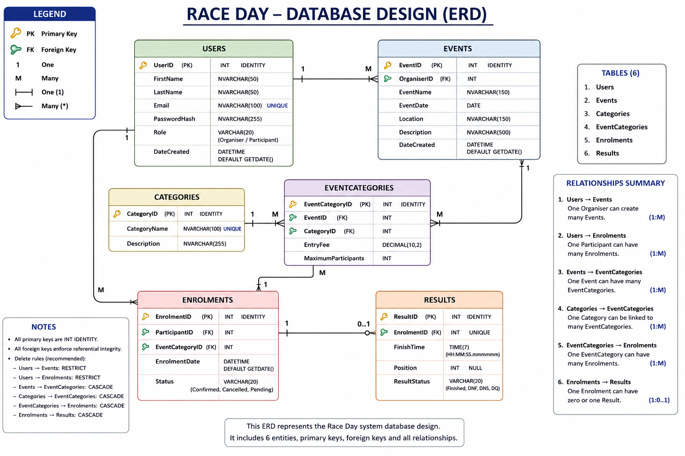

SQL Full script design and explaination.

Purpose:
Creates and populates the RaceDay database for Part 1.

The entire script.
*/
USE master;
GO
IF DB_ID(N'RaceDay') IS NOT NULL
BEGIN
ALTER DATABASE RaceDay SET SINGLE_USER WITH ROLLBACK IMMEDIATE;
DROP DATABASE RaceDay;
END;
GO
CREATE DATABASE RaceDay;
GO
USE RaceDay;
GO
/* ============================================================
- USERS
Stores both Organisers and Participants.
============================================================ */
CREATE TABLE dbo.Users
(
UserID INT IDENTITY(1,1) NOT NULL,
FirstName NVARCHAR(50) NOT NULL,
LastName NVARCHAR(50) NOT NULL,
Email NVARCHAR(100) NOT NULL,
PasswordHash NVARCHAR(255) NOT NULL,
Role NVARCHAR(20) NOT NULL,
DateCreated DATETIME NOT NULL
CONSTRAINT DF_Users_DateCreated DEFAULT GETDATE(),
CONSTRAINT PK_Users PRIMARY KEY (UserID),
CONSTRAINT UQ_Users_Email UNIQUE (Email),
CONSTRAINT CK_Users_Role CHECK (Role IN (N'Organiser', N'Participant'))
);
GO
/* ============================================================
2. EVENTS
Each event belongs to one Organiser.
============================================================ */
CREATE TABLE dbo.Events
(
EventID INT IDENTITY(1,1) NOT NULL,
OrganiserID INT NOT NULL,
EventName NVARCHAR(150) NOT NULL,
EventDate DATE NOT NULL,
Location NVARCHAR(150) NOT NULL,
Description NVARCHAR(500) NULL,
DateCreated DATETIME NOT NULL
CONSTRAINT DF_Events_DateCreated DEFAULT GETDATE(),
CONSTRAINT PK_Events PRIMARY KEY (EventID),

CONSTRAINT FK_Events_Organiser
FOREIGN KEY (OrganiserID)
REFERENCES dbo.Users(UserID)
ON DELETE NO ACTION
ON UPDATE NO ACTION
);
GO
/* ============================================================
3. CATEGORIES
Reusable categories such as 5 KM Run, 10 KM Run or Cycle.
============================================================ */
CREATE TABLE dbo.Categories
(
CategoryID INT IDENTITY(1,1) NOT NULL,
CategoryName NVARCHAR(100) NOT NULL,
Description NVARCHAR(255) NULL,
CONSTRAINT PK_Categories PRIMARY KEY (CategoryID),
CONSTRAINT UQ_Categories_CategoryName UNIQUE (CategoryName)
);
GO
/* ============================================================
4. EVENT CATEGORIES
Resolves the many-to-many relationship between Events
and Categories.
============================================================ */
CREATE TABLE dbo.EventCategories
(
EventCategoryID INT IDENTITY(1,1) NOT NULL,
EventID INT NOT NULL,
CategoryID INT NOT NULL,
EntryFee DECIMAL(10,2) NOT NULL,
MaximumParticipants INT NOT NULL,
CONSTRAINT PK_EventCategories PRIMARY KEY (EventCategoryID),

CONSTRAINT FK_EventCategories_Event
FOREIGN KEY (EventID)
REFERENCES dbo.Events(EventID)
ON DELETE CASCADE
ON UPDATE NO ACTION,

CONSTRAINT FK_EventCategories_Category
FOREIGN KEY (CategoryID)
REFERENCES dbo.Categories(CategoryID)
ON DELETE CASCADE
ON UPDATE NO ACTION,

CONSTRAINT UQ_EventCategories_Event_Category
UNIQUE (EventID, CategoryID),

CONSTRAINT CK_EventCategories_EntryFee
CHECK (EntryFee >= 0),

CONSTRAINT CK_EventCategories_MaximumParticipants
CHECK (MaximumParticipants > 0)
);
GO
/* ============================================================
5. ENROLMENTS
Links Participants to an EventCategory.
============================================================ */
CREATE TABLE dbo.Enrolments
(
EnrolmentID INT IDENTITY(1,1) NOT NULL,
ParticipantID INT NOT NULL,
EventCategoryID INT NOT NULL,
EnrolmentDate DATETIME NOT NULL
CONSTRAINT DF_Enrolments_EnrolmentDate DEFAULT GETDATE(),
Status VARCHAR(20) NOT NULL
CONSTRAINT DF_Enrolments_Status DEFAULT 'Confirmed',
CONSTRAINT PK_Enrolments PRIMARY KEY (EnrolmentID),

CONSTRAINT FK_Enrolments_Participant
FOREIGN KEY (ParticipantID)
REFERENCES dbo.Users(UserID)
ON DELETE NO ACTION
ON UPDATE NO ACTION,

CONSTRAINT FK_Enrolments_EventCategory
FOREIGN KEY (EventCategoryID)
REFERENCES dbo.EventCategories(EventCategoryID)
ON DELETE CASCADE
ON UPDATE NO ACTION,

CONSTRAINT UQ_Enrolments_Participant_EventCategory
UNIQUE (ParticipantID, EventCategoryID),

CONSTRAINT CK_Enrolments_Status
CHECK (Status IN ('Confirmed', 'Cancelled', 'Pending'))
);
GO
/* ============================================================
6. RESULTS
One enrolment can have zero or one result.
UNIQUE(EnrolmentID) enforces the maximum of one result.
============================================================ */
CREATE TABLE dbo.Results
(
ResultID INT IDENTITY(1,1) NOT NULL,
EnrolmentID INT NOT NULL,
FinishTime TIME(7) NULL,
Position INT NULL,
ResultStatus VARCHAR(20) NOT NULL,
CONSTRAINT PK_Results PRIMARY KEY (ResultID),

CONSTRAINT FK_Results_Enrolment
FOREIGN KEY (EnrolmentID)
REFERENCES dbo.Enrolments(EnrolmentID)
ON DELETE CASCADE
ON UPDATE NO ACTION,

CONSTRAINT UQ_Results_Enrolment UNIQUE (EnrolmentID),

CONSTRAINT CK_Results_Position
CHECK (Position IS NULL OR Position > 0),

CONSTRAINT CK_Results_Status
CHECK (ResultStatus IN ('Finished', 'DNF', 'DNS', 'DQ'))
);
GO
/* ============================================================
SEED DATA
Minimum required:
- 2 Organisers
- 2 Participants
- 3 Events
- Categories for every event
- Sample enrolments
============================================================ */
INSERT INTO dbo.Users
(FirstName, LastName, Email, PasswordHash, Role)
VALUES
(N'Nomsa', N'Mokoena', N'nomsa@raceday.co.za', N'REPLACE_WITH_HASH', N'Organiser'),
(N'Kabelo', N'Naidoo', N'kabelo@raceday.co.za', N'REPLACE_WITH_HASH', N'Organiser'),
(N'Cameron', N'Iyer', N'cameron@example.com', N'REPLACE_WITH_HASH', N'Participant'),
(N'Jordan', N'Pillay', N'jordan@example.com', N'REPLACE_WITH_HASH', N'Participant');
GO
INSERT INTO dbo.Categories
(CategoryName, Description)
VALUES
(N'5 KM Run', N'5 kilometre road running category'),
(N'10 KM Run', N'10 kilometre road running category'),
(N'21 KM Half Marathon', N'Half marathon road running category'),
(N'10 KM Walk', N'10 kilometre walking category'),
(N'40 KM Cycle', N'40 kilometre cycling category');
GO
INSERT INTO dbo.Events
(OrganiserID, EventName, EventDate, Location, Description)
VALUES
(1, N'Durban Spring Run', '2026-10-10', N'Durban, KwaZulu-Natal',
N'Road running event with multiple distance categories.'),
(1, N'Limpopo Heritage Cycle', '2026-10-24', N'Polokwane, Limpopo',
N'Community cycling event celebrating local heritage.'),
(2, N'Johannesburg Charity Walk', '2026-11-07', N'Johannesburg, Gauteng',
N'Charity walking event supporting a community initiative.');
GO
/* Event 1: 5 KM, 10 KM and Half Marathon */
INSERT INTO dbo.EventCategories
(EventID, CategoryID, EntryFee, MaximumParticipants)
VALUES
(1, 1, 100.00, 500),
(1, 2, 150.00, 700),
(1, 3, 250.00, 300);
/* Event 2: 40 KM Cycle and 10 KM Run */
INSERT INTO dbo.EventCategories
(EventID, CategoryID, EntryFee, MaximumParticipants)
VALUES
(2, 5, 300.00, 250),
(2, 2, 150.00, 400);
/* Event 3: 10 KM Walk and 5 KM Run */
INSERT INTO dbo.EventCategories
(EventID, CategoryID, EntryFee, MaximumParticipants)
VALUES
(3, 4, 120.00, 600),
(3, 1, 100.00, 500);
GO
INSERT INTO dbo.Enrolments
(ParticipantID, EventCategoryID, Status)
VALUES
(3, 1, 'Confirmed'),
(3, 4, 'Confirmed'),
(4, 2, 'Confirmed'),
(4, 6, 'Pending');
GO
/* Sample results are included to demonstrate the complete schema. */
INSERT INTO dbo.Results
(EnrolmentID, FinishTime, Position, ResultStatus)
VALUES
(1, '00:28:45', 34, 'Finished');
GO
/* ============================================================
VERIFICATION QUERIES
============================================================ */
SELECT * FROM dbo.Users;
SELECT * FROM dbo.Events;
SELECT * FROM dbo.Categories;
SELECT * FROM dbo.EventCategories;
SELECT * FROM dbo.Enrolments;
SELECT * FROM dbo.Results;
GO
/* Row-count verification /
SELECT 'Users' AS TableName, COUNT() AS RowCount FROM dbo.Users
UNION ALL
SELECT 'Events', COUNT() FROM dbo.Events
UNION ALL
SELECT 'Categories', COUNT() FROM dbo.Categories
UNION ALL
SELECT 'EventCategories', COUNT() FROM dbo.EventCategories
UNION ALL
SELECT 'Enrolments', COUNT() FROM dbo.Enrolments
UNION ALL
SELECT 'Results', COUNT(*) FROM dbo.Results;
GO
"""
workflow_yml = """name: Race Day Part 1 Validation
on:
push:
branches: [ main, master ]
pull_request:
branches: [ main, master ]
jobs:
validate-part1:
runs-on: ubuntu-latest

